Chapter 19, Problem 80.

Use PSpice to find the z parameters of the circuit in Prob. 19.7.

Chapter 19, Problem 7.

Calculate the impedance-parameter equivalent of the circuit in Fig. 19.71.

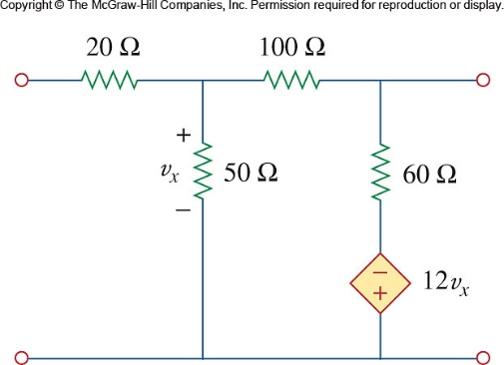

Figure 19.71
For Probs. 19.7 and 19.80.

